Album Cataloging Training Connexion Handout

Searching for Individual Records by OCLC Number
Open Connexion and login using the circled icon.
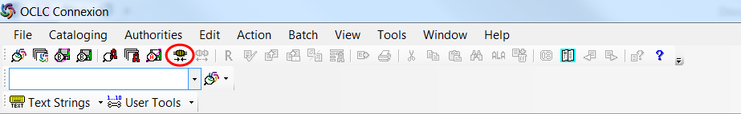
Then under the “Cataloging” menu select “Search” then “WorldCat” (or use F2).
In the Command line, type # and the OCLC number from the Sierra record and click “OK”.
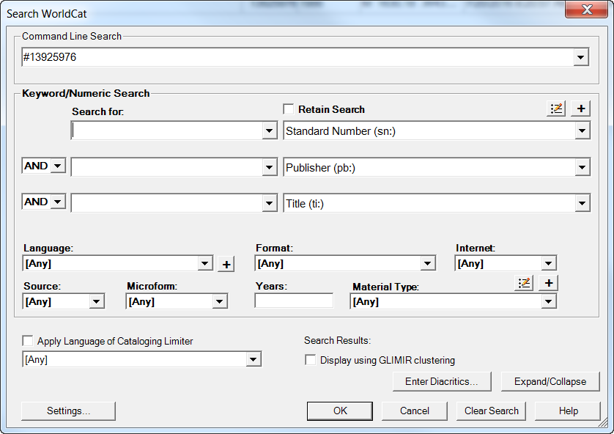
The top of the record should say “Held by EZF” if it’s a match.

Searching for Individual Records by Issue Number
Open Connexion and login using the circled icon.
Then under the “Cataloging” menu select “Search” then “WorldCat” (or use F2).
Select “Standard number (sn:)” from the drop-down menu and type the issue number.
If you do not get any results with the issue number, change the drop-down to “Title (ti:)” and try searching again.
If you get multiple records, try to use the best or most popular one after double-checking that we don’t have holdings declared on any record already. (If we do, use the one that already has our holdings.)
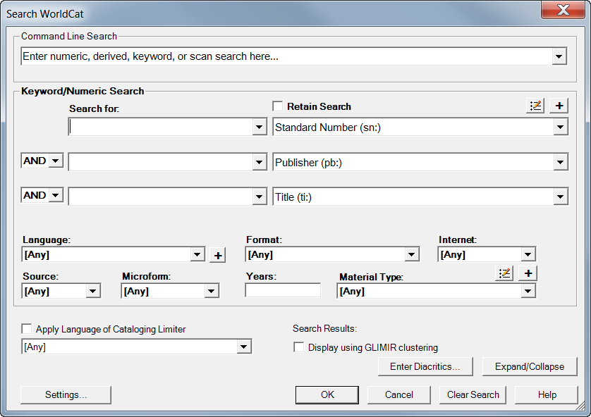

Searching for a Batch of Records
Batch searching is very helpful if you have more than one issue number and you’re not sure which one will bring up the best record. You can also search a whole cart full of OCLC numbers if you’d prefer to work on them incrementally instead of searching for each one as you get to it.
Open Connexion and login using the circled icon.
Then under the “Batch” menu select “Enter bibliographic search keys”.
Under the drop-down menu, be sure that the database with your name in it is selected.
If you are searching OCLC numbers, change the default index drop-down menu to “OCLC Number (no:)” and type # then each OCLC number, hitting enter after every entry. You should see each number added as a list in the big box below. After entering the whole list, click “Save” then “Close.
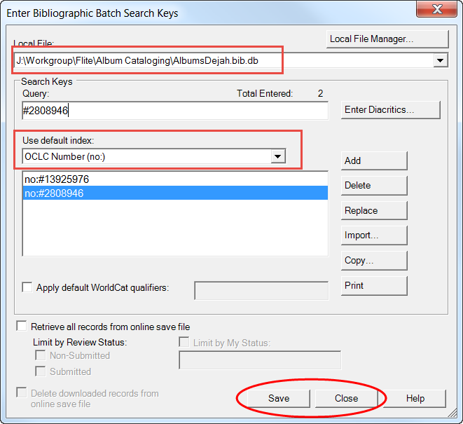

If you are searching issue numbers, change the default index drop-down menu to “Standard Number (sn:)” and type each issue number as written, hitting enter after every entry. You should see each number added as a list in the big box below. After entering the whole list, click “Save” then “Close.
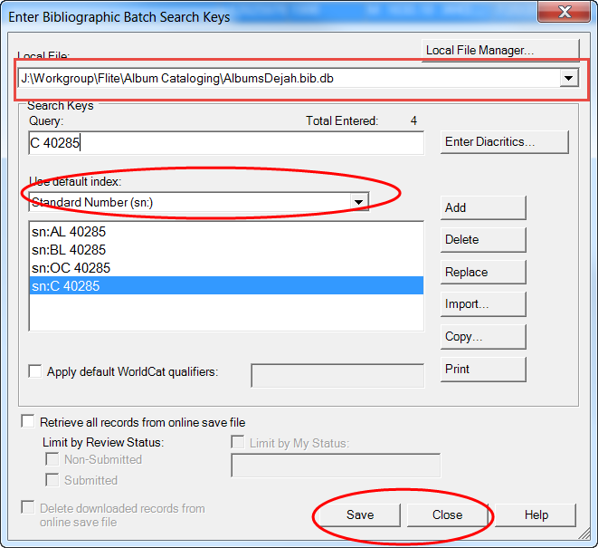
To search the entire batch, go to the “Batch” menu and select “Process Batch”
Under the local file path, be sure that the database with your name in it is selected
Then select “Online Searches” and click “OK”.
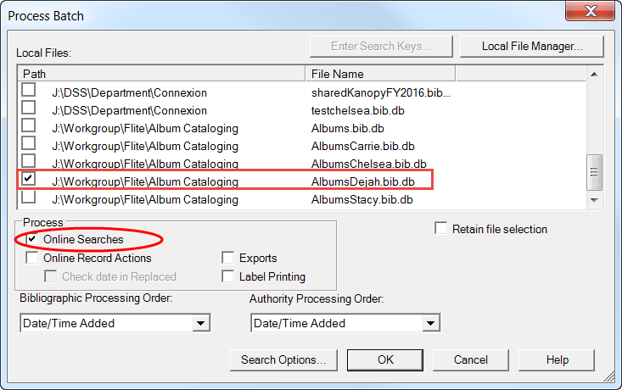
You will get a Batch Search Report when Connexion is finished searching. Close.
To open your records, go to the “Cataloging” menu and select “Show” then “By Local Save File Status”.
Then select the box next to “In Process” and click “Show Records”.
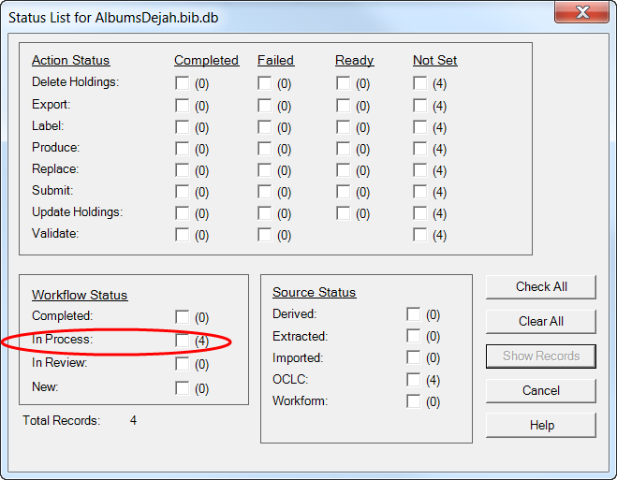
If you do not see any records marked as “In Process”, you may not be searching your database or you may have been disconnected while doing the batch search.
To double-check that you have downloaded the records to your database, go to the “File” menu and select “Local File Manager”. Your database should have a red check mark next to it. If it doesn’t, double-click it then close and try to show records again.
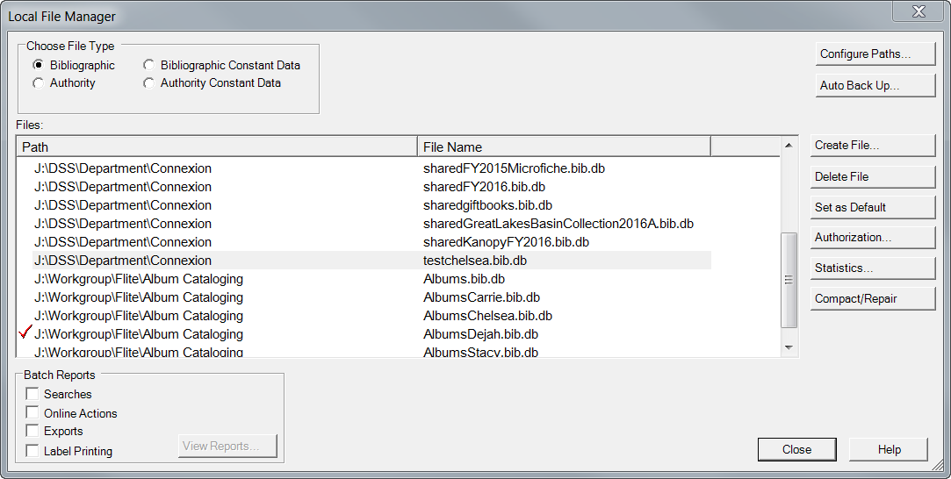

Editing the Leader and 008 Fields
The Leader and 008 fields in Connexion are all encoded in the big gray area at the top of the screen.
If you do not know what a code represents, click on the blue field tag to see all the options and double-check that what is entered is accurate.
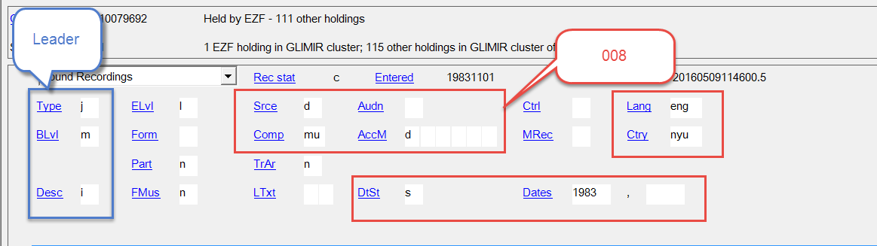

Editing 007 and Other Fields
To add a delimiter in Connexion, use [Control] + d
If the field text is in blue that means it is controlled. Click on the blue text to see the name or subject authority record.
To control your own fields, put your cursor in that field, right-click and select “Control single heading”.
Note: Connexion does not do as well as NACO/SACO does on finding authority records. So, if you do not get a match using Connexion, try searching NACO/SACO via the authorities website.
If you get any form of controlled authority, click on the name in blue and double-check that person matches the role you are seeking. For example, musicians shouldn’t have notes in the 670 field describing technical publications.
Use “Insert heading” or “Modify heading” to add controlled authorities.
If you’re confused about what a field means or its options, right-click on that field and select “MARC Field Help”.

Replacing Records and Updating Holdings
When you are done working on a record and are ready to send it back to OCLC, use the “Action” menu on the top toolbar and select “Replace Record and Update Holdings”.
To add the record to Sierra, go under the “Action” menu again and select “Export record”.

