Transferring Item and Other Records to a New Bib in Sierra

Look up the old record.

Set the Summary drop-down menu to “All” to ensure you are transferring the item, order, and any other records to the new bib record.
If you have multiple item records, you may have to select each one using the check boxes on the left to ensure every item will transfer.

Under the “Edit” menu, select “Transfer attached”.
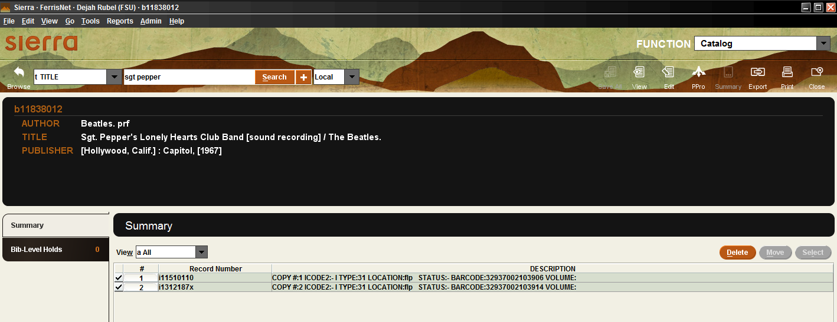

Enter the bib number (or title) to search for the new bib.

Click on the orange “Use Bib” button on the right side near the center of the screen.
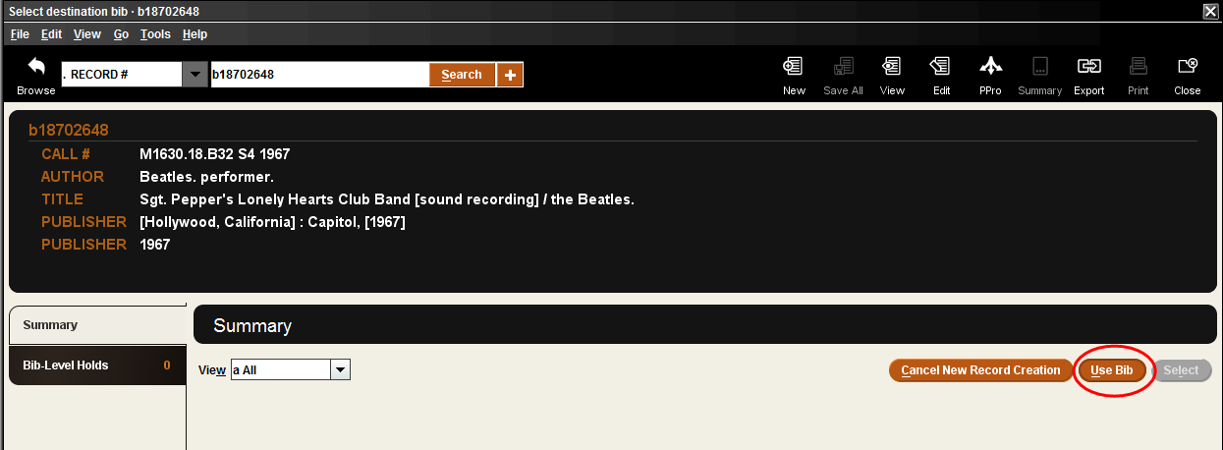

Select “Transfer all attached records, DELETE source bib” then “OK”.
